Project-Phase 1
  - Deadline: Day 26/07/2026 @ 23:59
[Total Mark is 5]

Computer Networks
DS360

Student Details: CRN:
Name: Ghalaa Talal Jebreen  Name:  Name: |  | ID:S240013894  ID:  ID:

Instructions:
- You must submit two separate copies (one Word file and one PDF file) using the Assignment Template on Blackboard via the allocated folder. These files must not be in compressed format.
- It is your responsibility to check and make sure that you have uploaded both the correct files.
- Zero mark will be given if you try to bypass the SafeAssign (e.g., misspell words, remove spaces between words, hide characters, use different character sets, convert text into image or languages other than English or any kind of manipulation).
- Email submission will not be accepted.
- You are advised to make your work clear and well-presented. This includes filling your information on the cover page.
- You must use this template, failing which will result in zero mark.
- You MUST show all your work, and text must not be converted into an image, unless specified otherwise by the question.
- Late submission will result in ZERO mark.
- The work should be your own, copying from students or other resources will result in ZERO mark.
- Use Times New Roman font for all your answers.

Project Instruction
Project Objective:
Design, configure, and test a network setup in Packet Tracer to successfully transmit data packets between devices in different LANs across two separate WANs (WAN 1 and WAN 2).
Group Details
- Group Size = Maximum of 3 Members.
- One group member (group leader/coordinator) must submit the project report on blackboard. Marks will be given based on your submission and quality of the contents.
Project Report
- The project is divided into two phases:
  - Phase 1 (Mid project Progress Report)
  - Phase 2 (Final project Report)
- This report is for Phase 1. In this report, you should complete all the requirements for Phase 1 only.
- Each Report will be evaluated according to the marking criteria

Project Description (Common to Phase 1 and Phase 2)
Learning Outcome(s):
Demonstrate protocol configuration, network-addressing schemes and analyze packet transmission for the Local and Wide Area Networks.

A university operates two campuses: a Main Campus and a Branch Campus. Each campus network is treated as a separate WAN site. Your task is to design and configure, in Cisco Packet Tracer, a network that successfully transmits data packets from a device in any LAN of WAN 1 (Main Campus) to a device in any LAN of WAN 2 (Branch Campus). Each WAN contains 2 LANs, and each LAN has 3 end devices.

Network Design Requirements:
- WAN 1 (Main Campus):
  - Contains LAN 1 (Computer Lab) and LAN 2 (Admin Office).
  - Each LAN has 3 devices (PCs or laptops) connected through a switch.
  - Assign private IP addresses to the devices in each LAN (e.g., use 172.16.10.0/24 for LAN 1 and 172.16.20.0/24 for LAN 2).
  - Connect each LAN to a router (Router 1).
- WAN 2 (Branch Campus):
  - Contains LAN 3 (Library) and LAN 4 (Faculty Office).
  - Each LAN has 3 devices (PCs or laptops) connected through a switch.
  - Assign private IP addresses to the devices in each LAN (e.g., use 172.16.30.0/24 for LAN 3 and 172.16.40.0/24 for LAN 4).
  - Connect each LAN to a router (Router 2).
- WAN Connection:
  - Connect Router 1 and Router 2 using a serial link to simulate a WAN connection.
  - Assign IP addresses to the serial interfaces (e.g., 10.10.10.1/30 for Router 1 and 10.10.10.2/30 for Router 2).

Configuration Details:
- Assign IP Addresses:
  - Configure IP addresses, subnet masks, and default gateways for all devices in each LAN. Example:
    - LAN 1: 172.16.10.0/24, Default Gateway: 172.16.10.1 (Router 1's interface).
    - LAN 2: 172.16.20.0/24, Default Gateway: 172.16.20.1 (Router 1's interface).
    - LAN 3: 172.16.30.0/24, Default Gateway: 172.16.30.1 (Router 2's interface).
    - LAN 4: 172.16.40.0/24, Default Gateway: 172.16.40.1 (Router 2's interface).
- Router Configuration:
  - Configure IP addresses on the LAN and WAN interfaces of both routers. Example:
    - Router 1:
      - LAN 1 Interface: 172.16.10.1/24
      - LAN 2 Interface: 172.16.20.1/24
      - WAN Interface (Serial): 10.10.10.1/30
    - Router 2:
      - LAN 3 Interface: 172.16.30.1/24
      - LAN 4 Interface: 172.16.40.1/24
      - WAN Interface (Serial): 10.10.10.2/30
- Enable Routing:
  - Configure static routes or a dynamic routing protocol (e.g., RIP) on both routers to ensure communication between WAN 1 and WAN 2.

Phase 1 Requirements
5 Marks
Students are required to submit a short mid progress report, which must include the following:
- Work completed this period (2 marks): This includes the installation of Cisco Packet Tracer, and a study of Packet Tracer for creating nodes, using different types of links (copper straight-through, copper cross-over, serial DCE/DTE), and assigning IP addresses.
  - Note: You must show a screenshot of the installation of Packet Tracer (with your system visible, e.g., date/time or username). (1 mark)
  - Give a description of the objectives and advantages of using Packet Tracer for this project. (1 mark)
- One key decision made during this period (1 mark): For example, your choice of IP addressing scheme, choice of routing method to study, or division of work among group members. Explain briefly why the decision was made.
- One problem encountered (1 mark): Describe one genuine problem faced so far (technical or organizational) and its current status (resolved / in progress).
- Plan for the next period (0.5 mark): Briefly list the tasks you plan to complete before the final submission (e.g., building the topology, configuring routers, testing with ping).
- Each group member's input/participation (0.5 mark): State each member's name and their specific contribution during this period.

Version History / Commit Log Requirements (Common to Both Reports)
Students must document and submit their project history/timestamps using a live, editable link:
- Written report: Submit a shared Google Doc or Word Online link (sharing set to "Anyone with the link can view") along with your final PDF report. The link must show the progress of the students' work with timestamps/screenshots.
- Code/data/configuration files: Submit Packet Tracer files (.pkt) and any configuration scripts via a GitHub or GitLab repository link (the coordinator may choose a repository suitable for the course). The repository must show a commit history reflecting incremental progress. Commit regularly (at minimum once per week), with clear, descriptive commit messages.
A separate section in the report must be added and named "Project Artifacts" to include all links, for example:
  - Live report document (with edit history): [link]
  - GitHub/GitLab repository (with commit history): [link]
  - Packet Tracer project file (.pkt): [link or attached]
What NOT to do: Students must not write their report elsewhere and paste the final version in at the last minute. They also must not make a single commit containing the entire project. Both are treated as red flags regardless of the quality of the final work.

Important Notes
- AI use: Students may use AI tools (ChatGPT, Claude, Copilot, Gemini, etc.) only for brainstorming approaches, debugging small errors, or proofreading text. AI must not be used to generate analysis, write configuration logic, or produce substantial portions of the report or project files. Any permitted AI use must be disclosed in the Reflection section. Undisclosed AI use, or AI use beyond this scope (disclosed or not), will result in a zero grade for the entire project.
- Any submission lacking a valid, inspectable version/commit history, or showing evidence of AI generation or plagiarism, will receive a zero grade for the entire project.
- Failure to submit the mid progress report as required, or submission of reports found to be fabricated, copied, or AI-generated, will result in a zero grade for the entire project.
- The mid progress report should be concise including screenshots.
- The same shared document link and repository submitted in Phase 1 must continue to be used for Phase 2, so that the full project history is visible in one place.

Project Artifacts
  - Live report document (with edit history):
https://1drv.ms/f/c/56587902647ea982/IgAeJS5sE9EDSKyNO93OOpaUAfhILpS0N_fQ7LDCips0COA?e=ntETfj

  - GitHub/GitLab repository (with commit history):
https://github.com/ghalaatalal/IT251-Project

  - Packet Tracer project file (.pkt): [link or attached]

- Work completed this period :
During this period our team completed the first steps required for the project
- Installed Cisco Packet Tracer and logged in successfully.

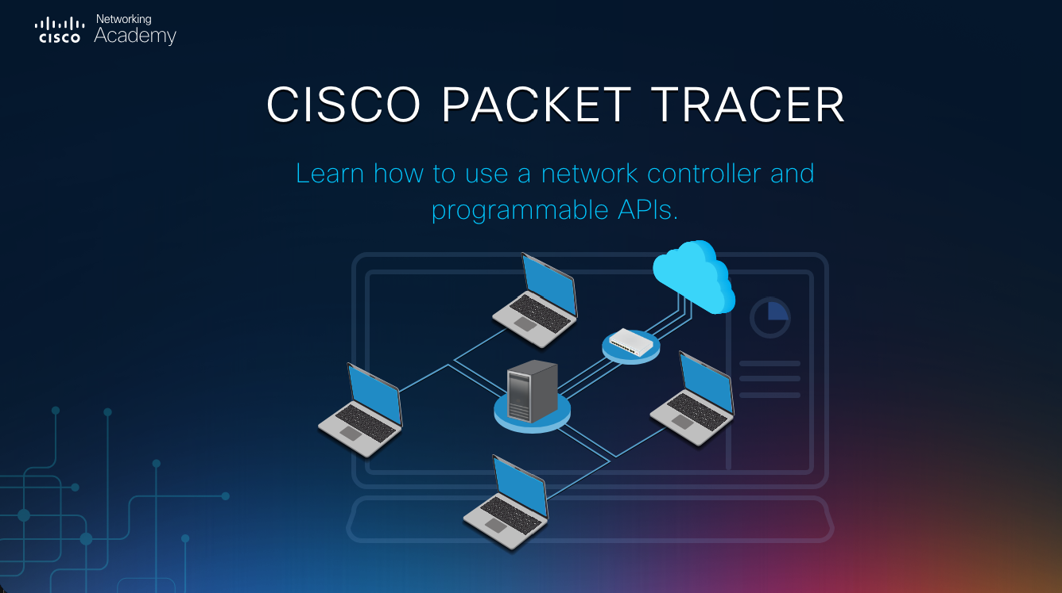

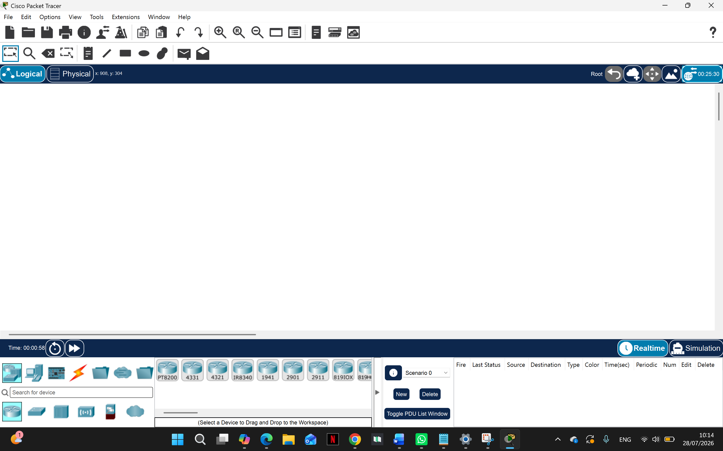

- Studied Packet Tracer features like
creating nodes like PC’s , Laptops , Switches & Routers
using different cable types such as Copper Straight- Through , Serial DCE
assigning IPv4 addresses to devices and routers

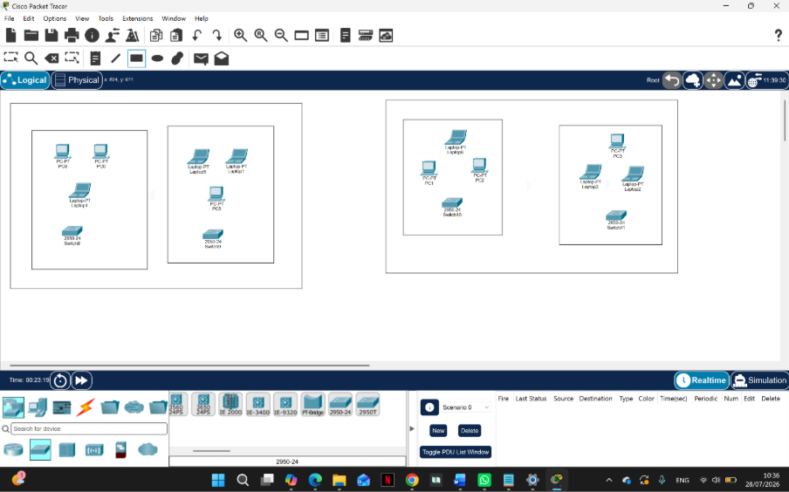
The

- Built 4 LAN’s :
LAN1: Computer Lab
LAN2: Admin Office
LAN3: Library
LAN4: Faculty Office

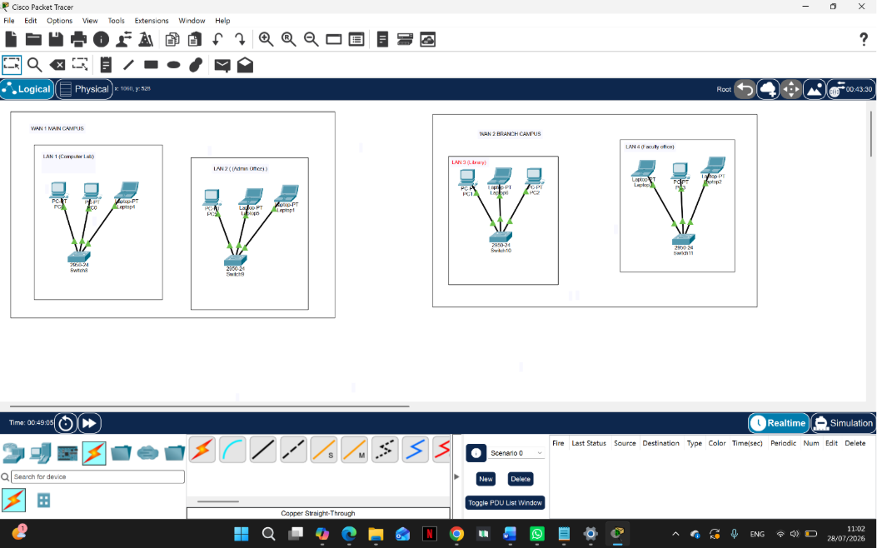

- Added Switches to each LAN and Organized the layout by surrounding LANs with squares and WANs with rectangles to avoid confusion
- Connected all the devices to switches using straight -Through cables

One key decision made during this period :
The tasks division was an important decision , assigning each student to do a specific part of the network to ensure clear workflow , Faster progress and Avoid confusion
One problem encountered :
The layout of the network was a little confusing during the wiring and I fixed it to make the wiring more clear
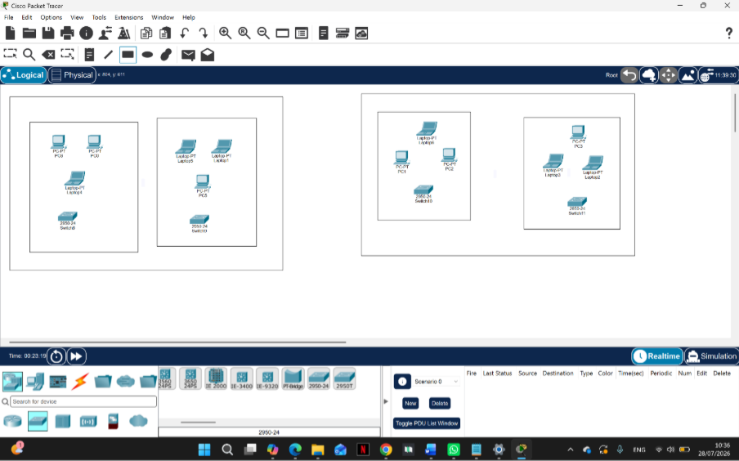
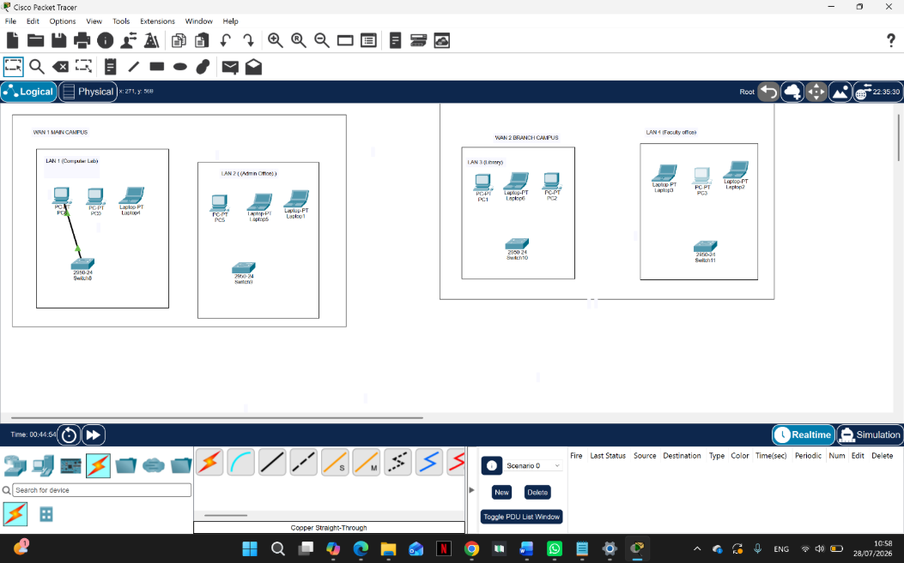

Objectives and Advantages of Using Cisco Packet Tracer :

objective of using Cisco Packet Tracer is to design and simulate the required network before implementation. It helps us connect devices, configure IP addresses, and understand how networks operate. Packet Tracer is easy to use, saves time and cost, and allows us to test the network and identify errors without using real networking equipment.

